**ASSIGNMENT-3**

**Name: chandru.P**

**Reg no: 713519CEIT008**

***PROGRAM FOR TRAFFIC LIGHT***

**Python Code:**

voidsetup(){

  // put your setup code here, to run once:

  Serial1.begin(9600);

  pinMode(21,OUTPUT);

  pinMode(20,OUTPUT);

  pinMode(19,OUTPUT);

}

voidloop(){

  // put your main code here, to run repeatedly:

  digitalWrite(21,HIGH);

  delay(3000);// this speeds up the simulation

  digitalWrite(21,LOW);

  digitalWrite(20,HIGH);

  delay(3000);

  digitalWrite(20,LOW);

  digitalWrite(19,HIGH);

  delay(3000);

  digitalWrite(19,LOW);

}

**OUTPUT:**

**Traffic Lights For Raspberry Pi**

**Blinking Red Light:**

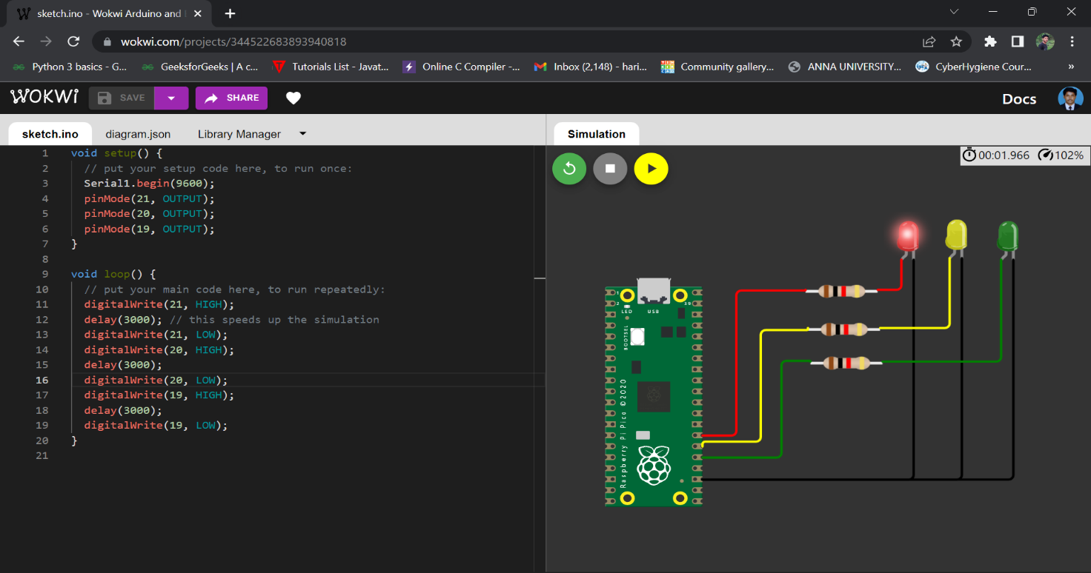

**Blinking Yellow Light:**

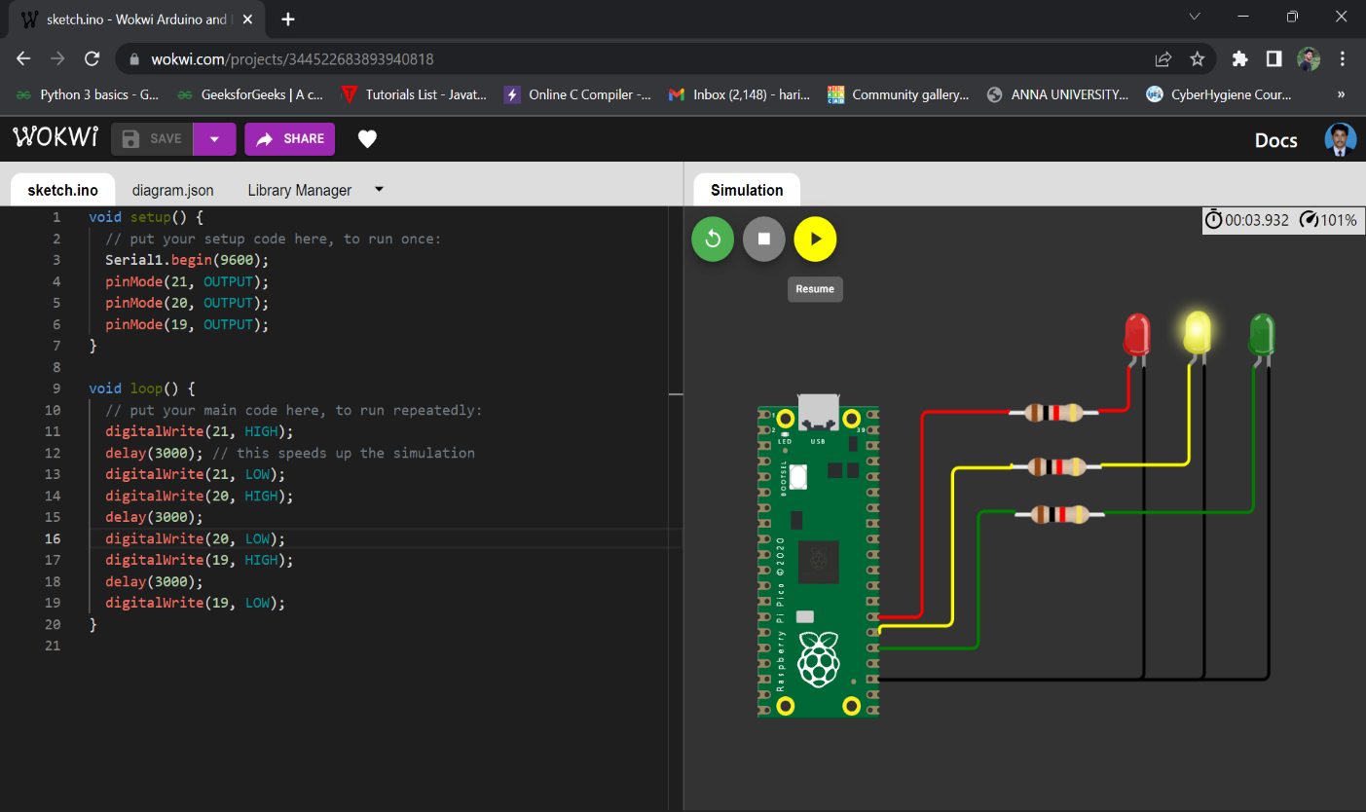

**Blinking Green Light:**

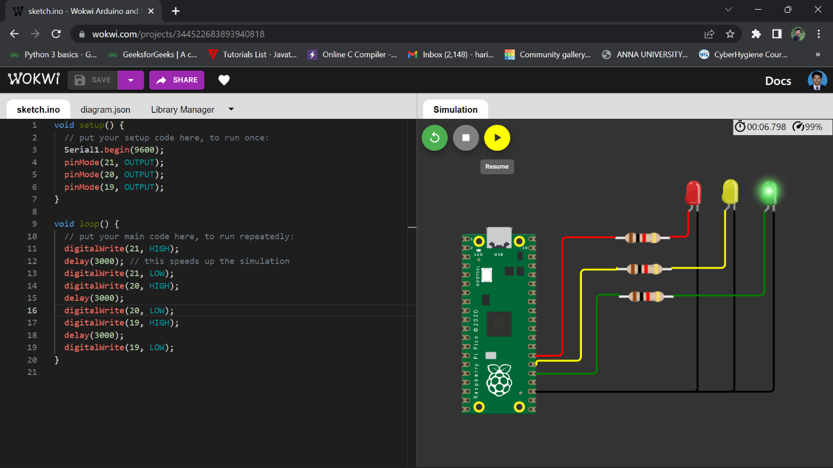

**BLINKING LED:**

**PROGRAM FOR BLINKING LED:**

**Python code:**

voidsetup(){

  // put your setup code here, to run once:

**Serial**.begin(9600);

  pinMode(22,OUTPUT);

}

voidloop(){

  // put your main code here, to run repeatedly:

  digitalWrite(22,HIGH);

**Serial**.println("LED ON");

  delay(2000);

  digitalWrite(22,LOW);

**Serial**.println("LED OFF");

  delay(2000);

}

**Output:**

**Blinking LED For Raspberry pi:**

